**Social Related**

**Tagger-** Create social posts anywhere and tag them to a location. For example if you are on a hike you could tag posts to a tree or hill and others could like or comment on them.

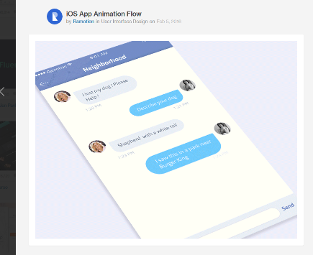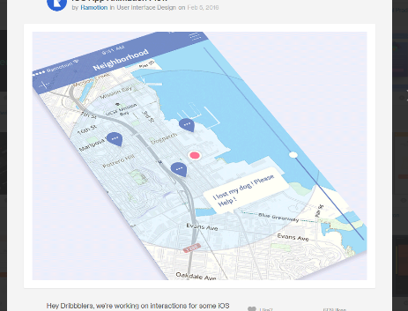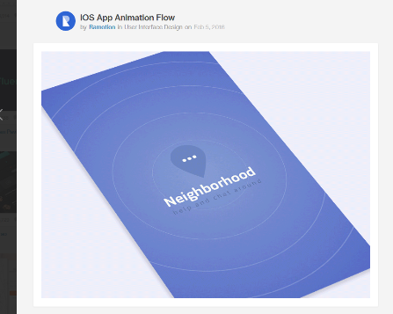

**Release-** This is a site/mobile app where you can find and follow anything that interests you. There will be a personal feed of anything about what you are following and also a landing global/trending page of what is trending and interesting. For example you could follow a favorite band, an author, quantum physics or something else to get any new updates about them. You could also follow a sports team for live updates whenever they are playing.

**Social Journal (App)-** Kind of like a diary or journal but you can share it. It is social media that tells more of a story. So for instance if you made a post about going to Sunriver you could post lots of photos and text about it and all the likes would accumulate under Sunriver. You also can create group posts so if all of your friends went to Sunriver everyone could post and write to that entry that you invite. It has a follow model like Twitter.

**File Sharing Site-** A site where you can add friends then share files with them easily. It is not a social network more a tool like a combination of Dropbox and Facebook but without making posts but you can click a file and chat about it.

**Kite (Website)-** A site where you can create boards and add posts to them. People can follow boards they like and this is added to your total followers. For instance I could make a my favorite music board and post videos I like to that board.

**Evently-** A mobile app that allows you to follow groups and see all the events they are having. It also allows you to browse and find events by category.

**Group Collaboration Site (No Name)-**

**Gift Suggestion Guide-**

**Homstac-**

**Release-**

**Kite -** A sharing site like Pinterest and Twitter where you make and follow boards

**Kite-** (Same Name Different Idea)

**Evently-** A site to create, find and manage events

**ShareShare-** A site to create and share with groups

**Email-** A better email list server, it is social and you can manage all emails including choosing to see activity but not receive emails

**Wishlist-** A site to create and share lists of things you want

**Business or Website Related**

**Hosting Company-** This would be a more simple hosting company geared towards bloggers or anyone who is not technical wanting to make a website. It could be built on top of Amazon Web Services

**Software Blueprint-** This is just a pure website but it could be kinda like a directory of all the different front end and back end code, tools frameworks and options. An example would be you would click a mobile image then click login and it would display potential NPM packages, google packages or other code related to building a login system. Its just informational but could be useful and maybe later we could allow people to rate the different options like should I use Vue.js or React.js, or Amazon Web Services, Heroku or Google App Engine.

**Employee Shift Scheduler (No Name)-** This would allow employees to set their ideal schedule online. Like I prefer not working late nights but don’t mind working a lot of days in a row. The software would keep all their requests and use AI to put together the best schedule to maximize all employees preferences. It would also track employee and store employee happiness overtime. This would include things like Holidays worked, overtime, etc

**Shiftswap-** This is a similar idea to the above but would be a mobile app and website making it easy to pick up or change shifts. You could put in to the app I want someone to work for me tomorrow and everyone with the app would get the notification (you can also have it text you if you want). If someone picks it up it would go to the managers app for approval then send out a notification it has been approved. It can also help managers find someone to come in last minute.

**API Creator-**

**Modern Communication for Groups**